VisitCurrituckOBX Battle in the Blue Ridge Basketball Tournament Analytics
November 23-25, 2018, Asheville, NC

Each fiscal year, the majority of our marketing decisions rely on past performance and metrics to make sure we are getting the best ROI. Our tried and true advertisers are Google Ads, Southern Living, and digital display ads to name a few. When we purchase advertising, we look at many different factors such as:

- Is it appropriate for our demographics?
- Does it reach our target markets?
- Is it cost effective?
- What is the audience size or distribution?

While all of these factors are important, sometimes in marketing, you try something new to see if it works. It might only fit some of your criteria, but you see a potential for success and take a chance.

We use a small portion of our overall budget every year for new initiatives that we feel have potential to raise brand awareness and put us ahead of the curve compared to our competitors. Here are some new initiatives we are currently working on:

- AWOL (Air, Water or Land) – A brand new streaming Amazon Prime Series that is geared towards millennials and their travel habits
- Longer format TV series – A self-produced long format promotion piece that would be run through Over the Top (OTT) networks in various markets (think ROKU) - similar to on-demand content you can find currently with cable providers

Advertising with a sporting event was a new marketing venture for us. Even though it is labeled as a “sponsorship,” this was a purchased advertising program for Currituck Outer Banks. The decision to use a tournament as a marketing medium was to create brand awareness in a way that we have not ventured to use before. Several factors played into our decision. For example, we looked at additional demographics of basketball fans.

Men’s NCAA Basketball Fan Demographics (Source: Scarborough USA Plus Research):

- Men’s college basketball attracts an affluent and well-educated audience
- Age Range – 66% are above the age of 35
- Home Ownership – 73% own their home
- Education – 66% have a college education
- HHI – 16% have a HHI of $100k – 150K | 13% have a HHI of $150k or higher

With over 65% of travelers now using mobile devices to research and book travel destinations, we wanted to reach potential travelers to Currituck Outer Banks via online content provided by the advertiser to create brand awareness and to get them to land on our website. Also, this tournament fit several of our criteria when examining the possible effectiveness of a campaign. All the teams, with the exception of Arkansas, which we looked at as a test market, were in our feeder markets. North Carolina is our biggest feeder market, and not only were two of the teams from NC, the tournament was in Asheville, NC and locally would reach the greater metro area of Asheville, particularly with the outside marquee at the Arena.

After the tournament we looked at the website statistics for the week before the tournament and the week after and compared it to the same time frame in 2017. This time frame was November 18 through November 30 for both 2018 and 2017.

In order to make sure that we did not have any advertising programs or other outside influences that could have a direct effect on the numbers, we looked at the Thanksgiving holiday dates to see if they fell with the same range. Thanksgiving this year was on November 22 and last year was November 23, so we determined that this did not have an effect. We also looked at our paid online advertising during this time frame and compared it to the same period in 2017. The difference in spend was negligible, so we determined this was also not a factor.

Google Spend:

- 2018 - $2412.06
- 2017 - $2336.57
- 2016 - $5,970.88

Factoring out any possible advertising that could affect the statistics other than the advertising for the basketball tournament, we were looking to see if digital advertising had an effect on our website statistics. We were very pleased with the outcome, particularly in the conversion statistics. Conversions are very highly qualified potential visitors because they have taken the time to actually look more in depth at our destination when considering vacation plans and downloaded or requested information.

Overall Website Stats:

- Users – Increase of 24.69%
- New Users – Increase of 24.55%
- Page Views – Increase of 23.18%

Web Visits by Geography:

- Charlotte Metro – Increase of .36%
- Wilmington NC – Increase of 346%
- Asheville NC – Increase of 73%
- Arkansas – Increase of 16%
- Illinois – Increase of 10%

Conversion Actions:

- View Digital Visitor Guide – Increase of 152%
- View Digital Wedding Guide – Increase of 81% (no wedding advertising during this period)
- View Digital Shopping & Dining Guide – Increase of 213%
- Request a Physical Visitor Guide – Increase of 212%

We were more than pleased with this increased activity which we directly attribute to the tournament.

Another way we can measure a digital advertising campaign for effectiveness is through digital impressions.

Definition:

Impressions are when an advertisement or any other form of digital media renders on a user's screen. Impressions are not action-based and are merely defined by a user potentially seeing the advertisement, making Cost Per Thousand (CPM) campaigns ideal for businesses intent on spreading brand awareness.

Impressions in Digital Marketing:

Digital marketing has made impression tracking significantly more quantitative than offline advertising. For example, a billboard owner has no concrete way of estimating the number of impressions his platform grants advertisers. Impression-based online campaigns, on the other hand, can measure impressions concretely, and are generally sold in terms of cost-per-thousand (CPM) impressions.

Impression tracking is a common metric for measuring the performance of most types of online marketing campaigns.

Promotion from Explore Asheville CVB

- Event List on ExploreAsheville.com Event Calendar – 349 page views
- Featured event in Asheville Traveler E-newsletter – Sent to 123k subscribers
- Things to Do blog post – 6046 page views
- Sporting Events blog post – 248 page views
- Dedicated Facebook post – 7,731 reach
- Things to Do Facebook post – 12,926 reach
- Twitter Posts (4 total) – 4,520 impressions
- Dedicated microsite to promote hotel rates – 130 page views
- Dedicated email to lodging partners – 328 contacts in Asheville and surrounding areas

Impression Perspective:

For the sake of comparison, we spent close to $225k in Google Ads during 2018 and received 4,308,506 impressions. This is not clicks, but strictly how many times our ad appeared in from of someone doing a search or viewing a page that was part of the Google Ad Network.

Adding up impressions from the following sources, the impressions garnered by the tournament was a total of 34,115,810:

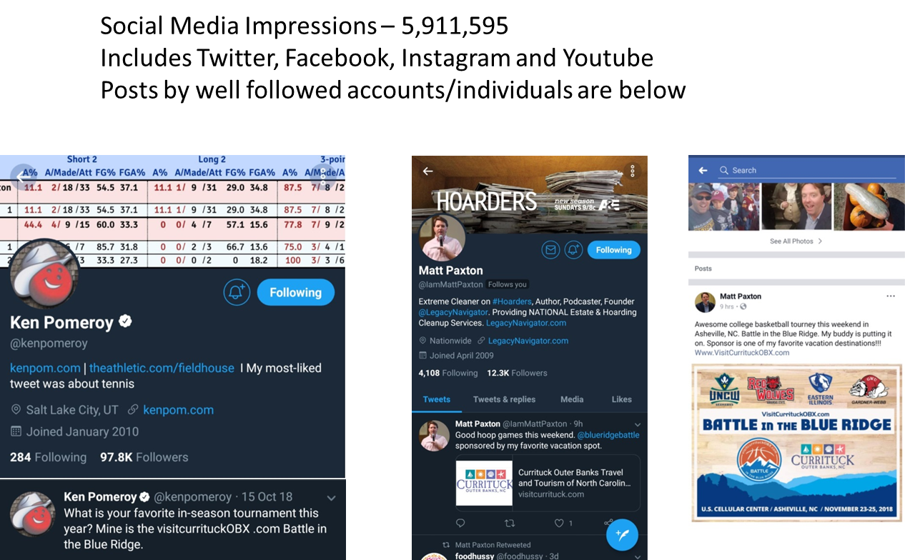

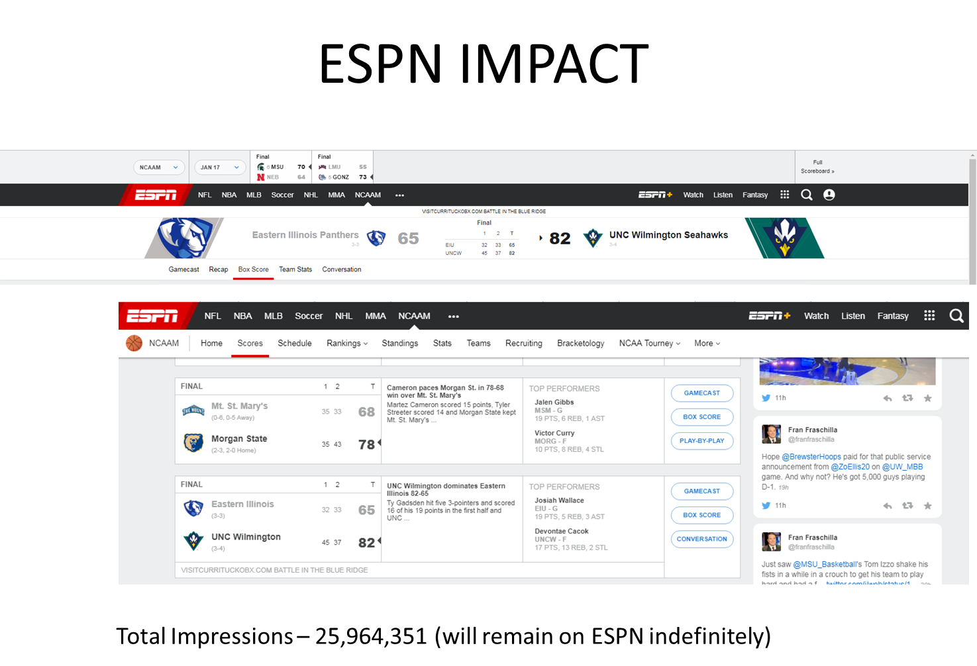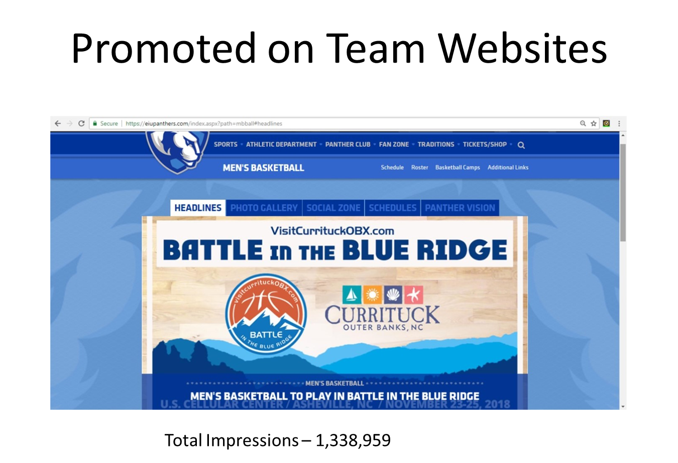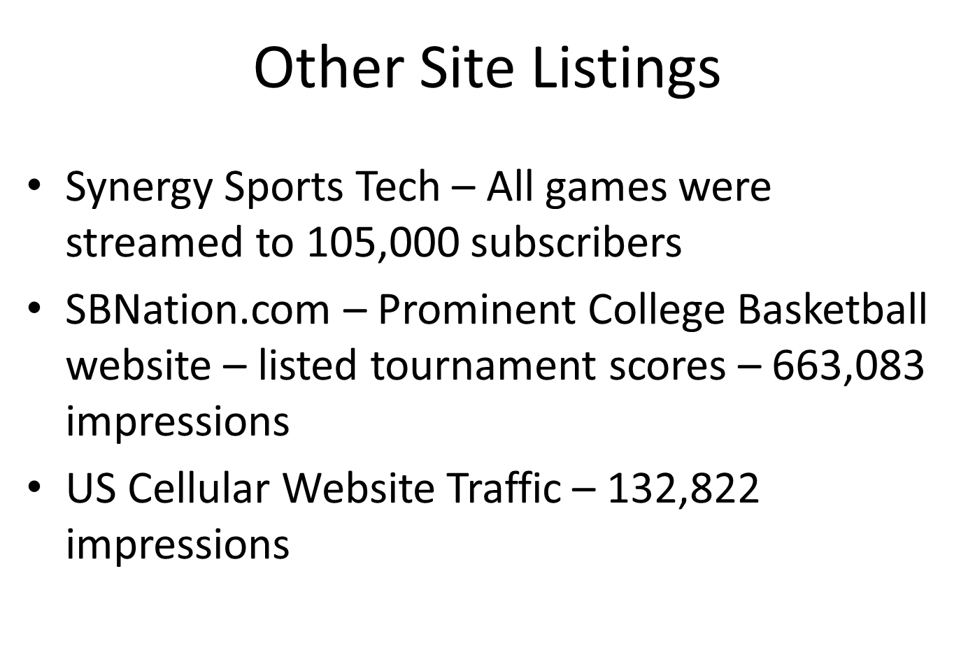

Other types of impressions that were utilized but not counted in the above figures included:

- VisitCurrituck beach towels, coolers, pens, lip balms, drawstring backpacks and visitor guides
- VisitCurrituckOBX.com t- shirts with the Currituck logo on the reverse side
- VisitCurituckOBX.com bucket-hats as team gifts

What does this mean in potential economic impact?:

On average, the daily spend by a visitor party in Currituck Outer Banks is $2,757 and includes lodging, food, entertainment, shopping and transportation. If you multiply that by 7 days, the total per week per visitor party is $19,300. If we are able to attract 20 visitors from our conversions during the two week time frame of the tournament, this equates to $385,999 in visitor spend for a $50,000 investment. We only need to have attracted 3 visitors at $57,900 to make up for our initial advertising investment.

